

Ana Maria Hysa

**PHASE III: SOFTWARE DESIGN AND MODELING.**

**Project Title: Job-Seeking Portal, “FindYou”**

**Prepared by:**

Adela Spaho

Ana Maria Hysa

Dea Rucaj

Kejti Vakeflli

Xhesi Qordja

**CEN302 – SOFWARE ENGENEERING – EPOKA UNIVERSITY**

Software Design

**User Scenarios:**

A user scenario is the fictitious story of a user accomplishing an action or goal via a product. It focuses on a user’s motivations and documents the process by which the user might use a design.

**Client Scenarios:**

1. *Client Register and Login*
   1. The client accessesthesystem.
   2. The platform asks for a username, password, and relevant data.

b. The client enters the data.

c. If the data is correct, the client is registered successfully and if the data are incorrect, an error message pops up.

1. *Client Settings*
   1. The client logs into her account.
   2. After she clicks push the settings button in the menu, she inserts the data that she wishes to update and/or the new password on a readymade form.
   3. The system will ask for the password (the old one if she is changing it).
   4. After entering the password, she saves the changes, and the page reloads so that she can see the newly updated data that she inserted previously.
2. *Client Appointment Booking:*
   1. The client logs in with her personal account.
   2. In her personal account, there is a calendar where she can see which day and hour is free so that she can book an appointment.
   3. The client finds the date on which she will leave the appointment and selects it on the calendar.
   4. An appointment data form will be displayed, which she completes with the time and services she wants to receive and then simply sends it.
   5. In the end, her appointment status will be pending.
3. *Client Approval / Disapproval of Appointment*
   1. If the appointment is approved, the client will receive a successfully booked message.
   2. If the appointment is not approved, the client will receive a disapproval message.
   3. In the second case, either the appointment is completely canceled due to overbooking, or by clicking the message, the client can reschedule the appointment at a time specified in the message.
4. *Client Discount Points*
   1. After every service and purchase, the client will receive bonus points.
   2. Those points will be sent and displayed on her account by the system where she can use or redeem them later.
   3. With those points, she will receive discounts or other benefits.
5. *Client Appointment Stored*
   1. The client can find her stored appointments in her account.
   2. She should enter the previous appointments displayed on the menu and there can find all the stored previous appointments that she has already completed.
6. *Client Gallery*
   1. After logging in her account, the client will see a good size screen that is dedicated to photos and pictures, maybe even short videos.
   2. The client can find there her own photos or photos of the salon.
   3. Photos will be directly appearing in the dashboard as a slideshow gallery; therefore, she will not need to do anything to see the photos.
7. *Client Logout*
   1. Presses Logout on the top left side of the page to lock out of her account.
   2. For their security, the password is not saved.

***Use Cases***

***Admin Use Case***User Scenarios

A user scenario is the fictitious story of a user accomplishing an action or goal via a product. It focuses on a user’s motivations and documents the process by which the user might use a design.

1. ***Case 1:***

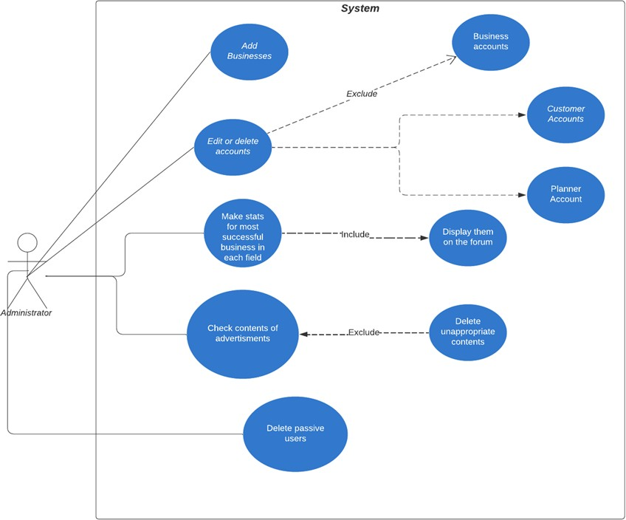

1. ***Customer Use Case***
2. *Admin Login*
   1. Admin enters his/her credentials.
   2. If credentials proven correct, admin is redirected to the Admin Dashboard.
   3. Otherwise, an error message pops up and the administrator is asked to re-enter accurately his/her credentials.
   4. Once logged in, the Admin Dashboard including a dropdown menu, business statistics, the appointments calendar for the current day, quick reports generation, information regarding employees having their birthday, and a sign out button, reveals itself. This would be the home section of the menu.
   5. 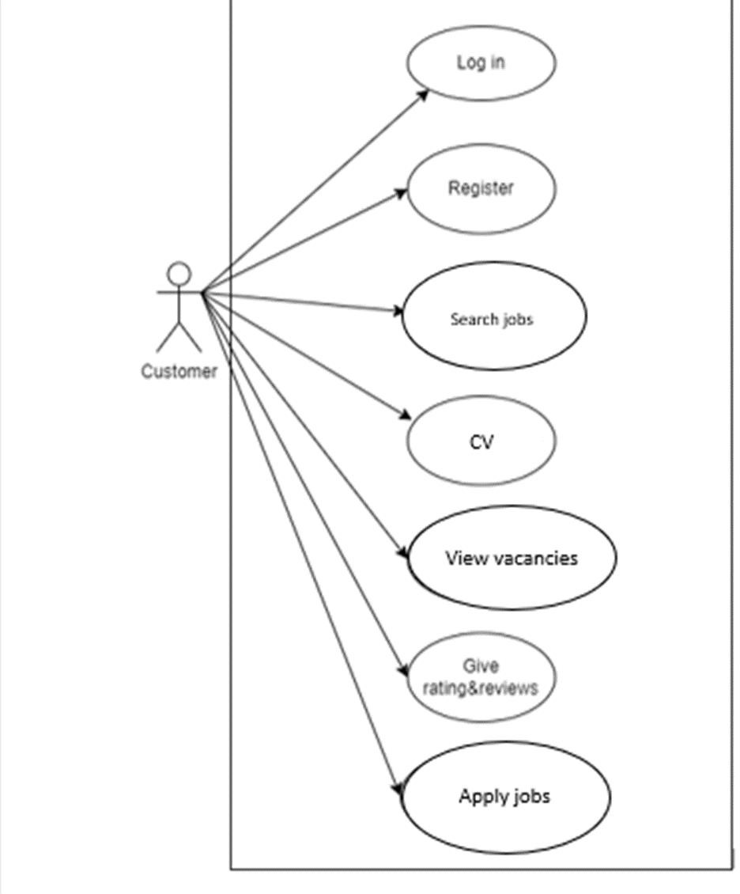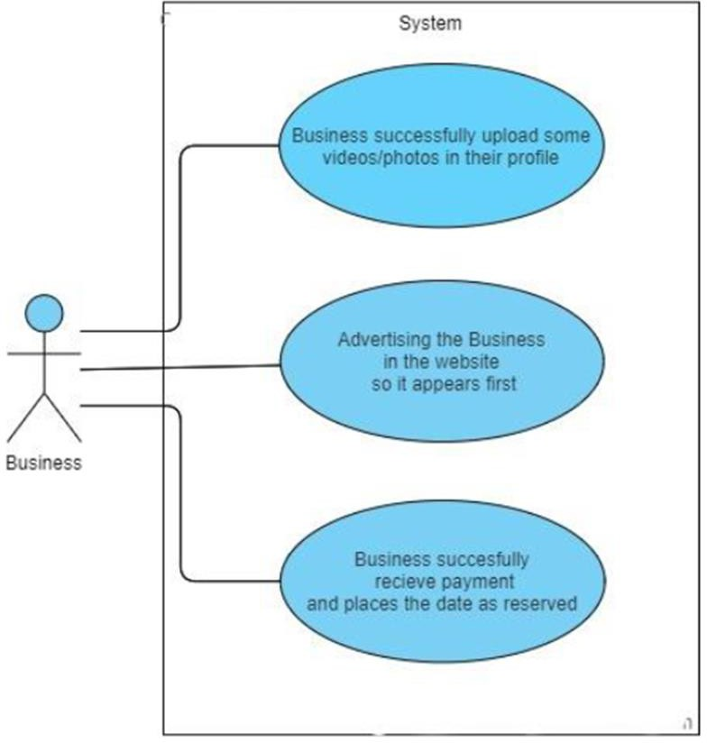Admin can generate PDF files of the reports listed under the Quick Reports

***Activity Diagrams***

1. ***Login***

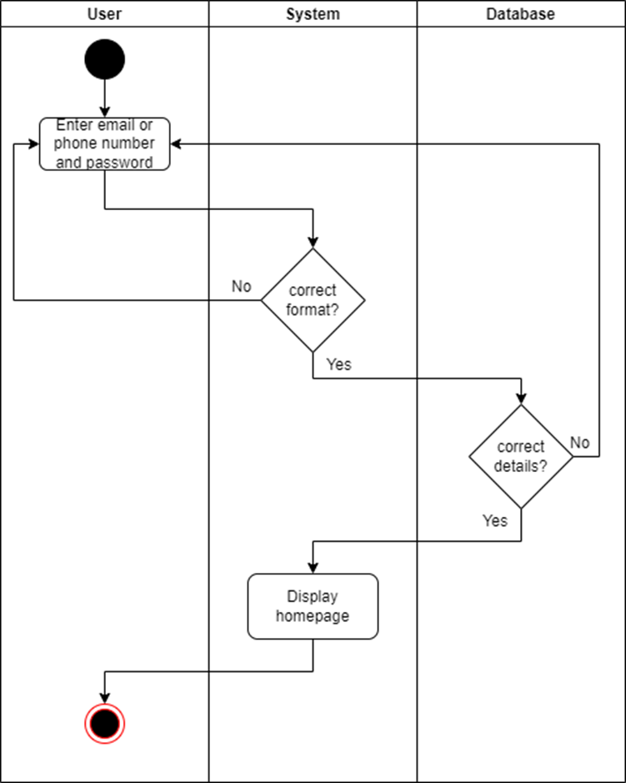

1. 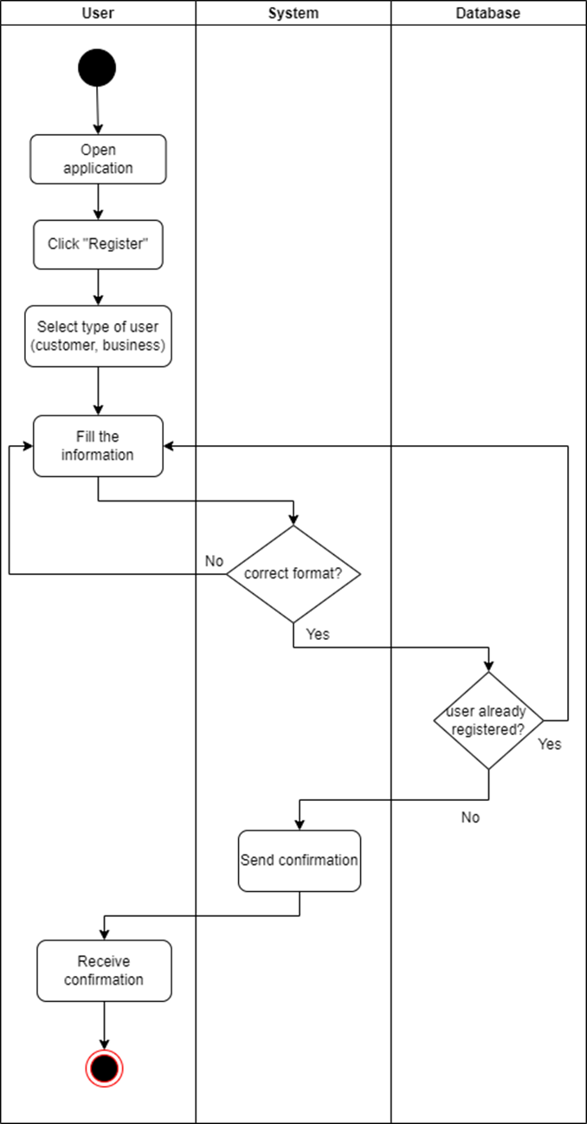***User registration***
2. ***Change password***

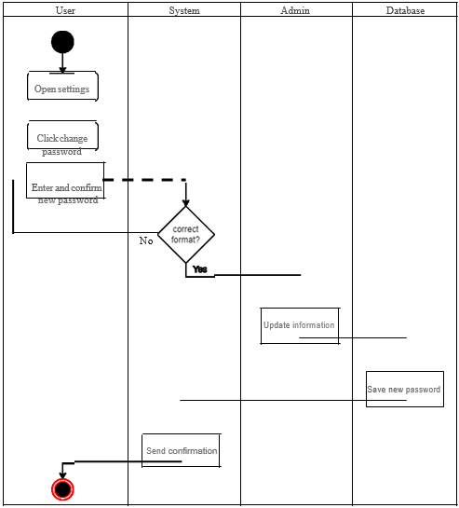

1. 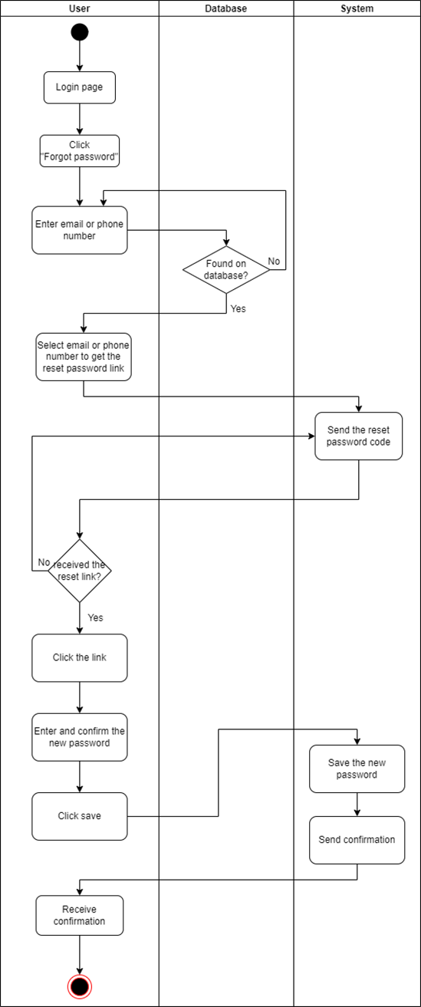***Forgot password***
2. ***Check contents***

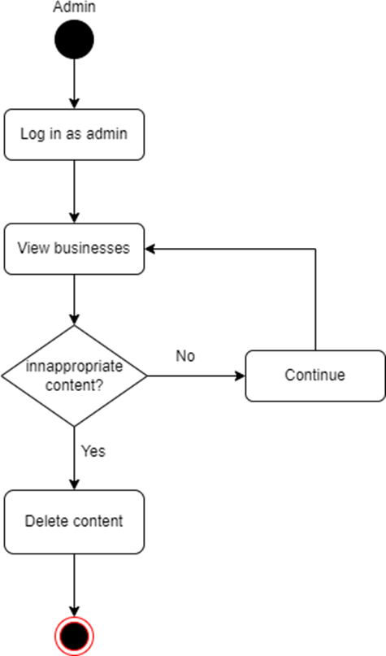

1. ***Delete inactive users***

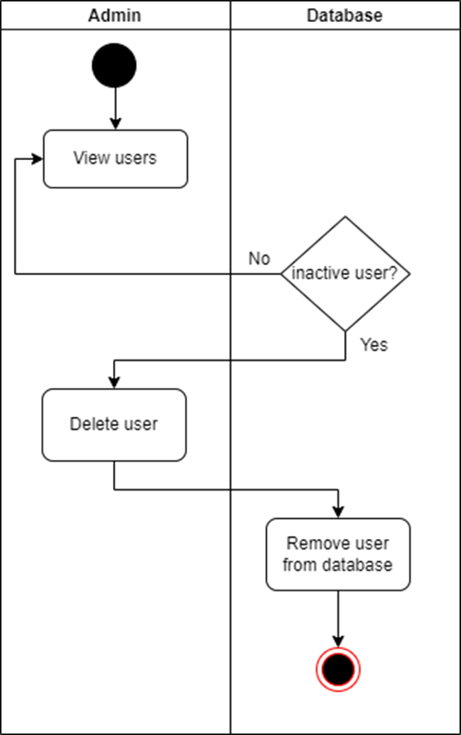

1. ***Manage events***

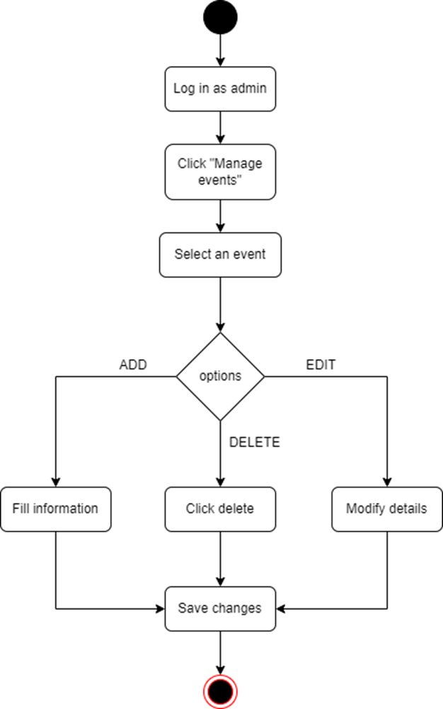

1. ***Management***

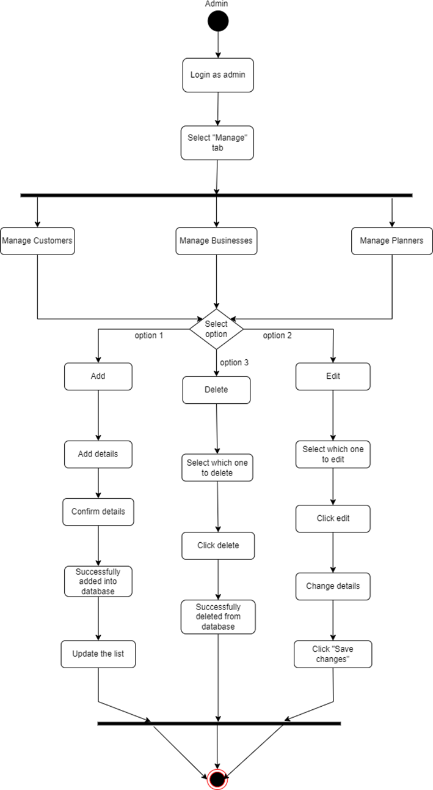

1. 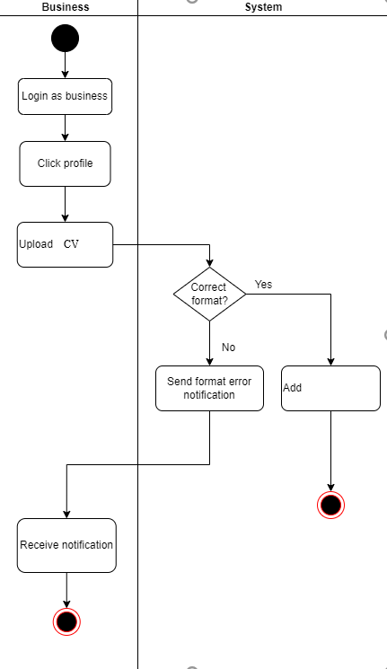***Upload CV***
2. 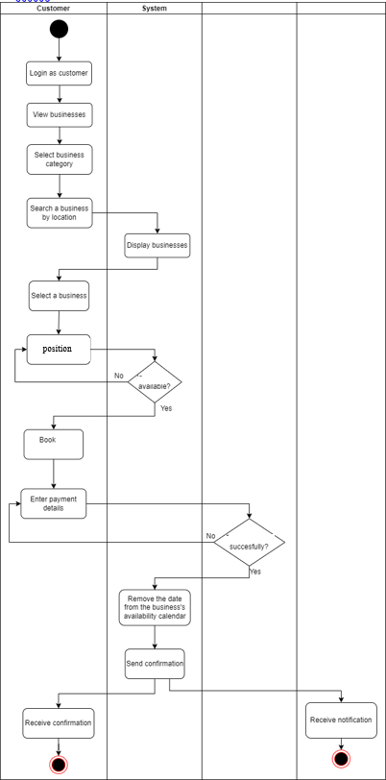***Job Advertisement***

***11. Edit info***

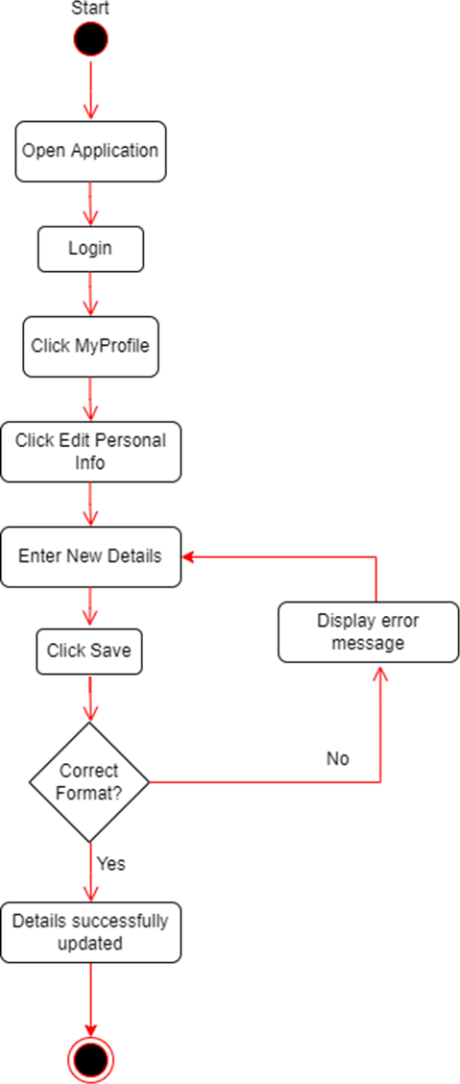

## Customer Scenarios (9)

1. ***Customer Login***
   1. Enters email and password.
   2. If the email and password are correct and match the database, they are redirected to the customer home page.
2. ***Customer Login fails***
   1. Enters email and password.
   2. If they do not match in database than error notification displays letting you know something is incorrect.
3. ***Customer Information***
   1. User logs in their Employee Dashboard.
   2. Displayed will be all their information in a nice aesthetic design.
   3. Salary and Vacation Days will be displayed in two information boxes.
4. ***Customer Settings***
   1. Employee has the right to change their password and personal info.
   2. By going on to the settings, the page directs them to where they can change their info if they wish so.
   3. Enters the new password and/or personal info.
   4. For security issues, they are required to reenter their (old) password if they want to save the changes to their information.
   5. The restriction is that they cannot change their salary.

***ST_01 Login***

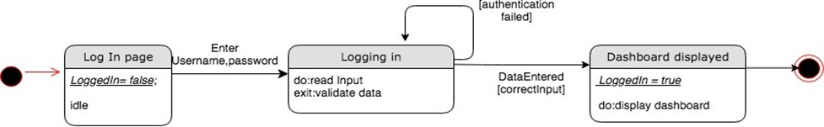

***ST_03 Log Out***

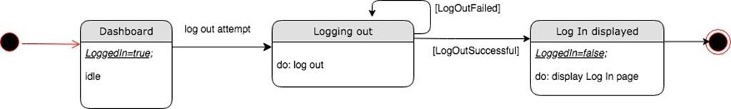

***ST_10 Register as an Employee***

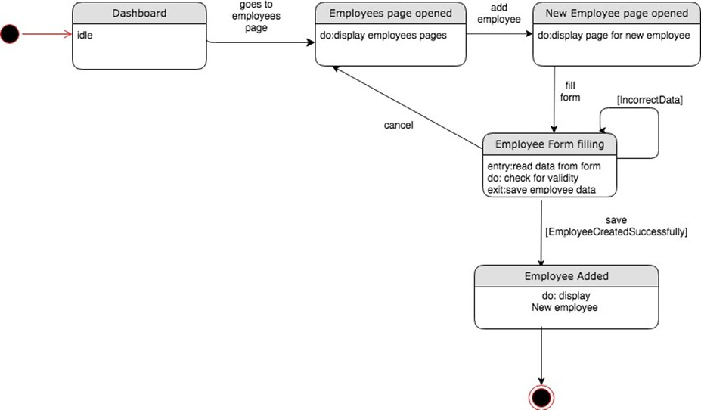

***ST_15_16 Accept, Reject Employee Request for job***

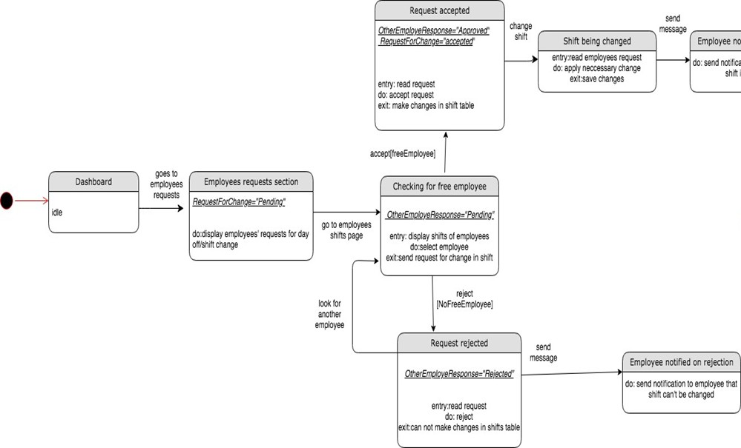

**1 - Input Applicant's CV:**

To us, every client is a new invoice derived – which means invoices billed to people using the software, are linked to them, whenever they create the account. The logic follows as seen below:

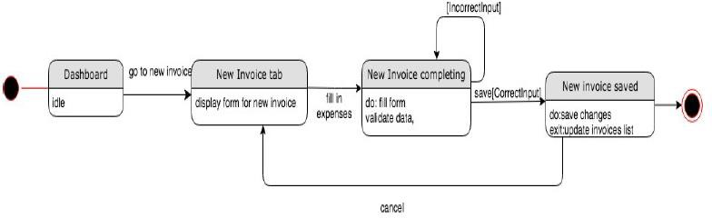

**2- Create personal account:** We made this diagram, to show how the logic decision making is applied whenever we created this software.

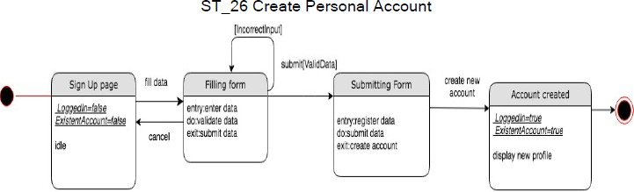

1. **– View completed CV and client’s CV profile:**

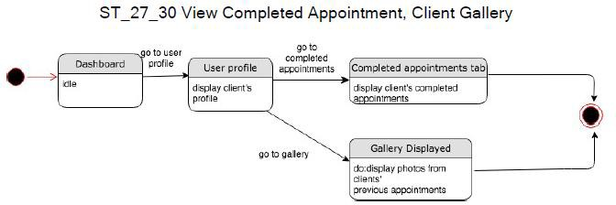

1. **– Sequence and collaboration Diagrams:**

**A: Log in:** This is the first step to creating a User log in on FindYou application. Please see below:

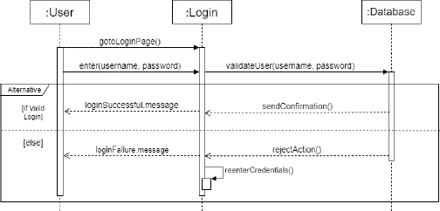

**B: USER LOG IN:** Every user will have their own log in, followed by the Decision dashboard – linked access granting. Access will not be granted, unless we can upload the log in name, email, client’s personal and professional information.

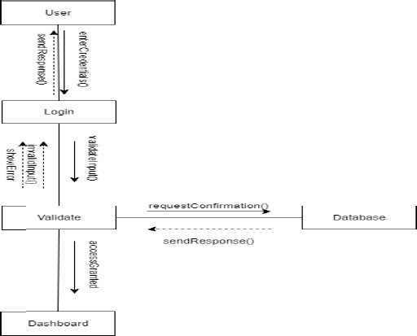

**C: UPDATE SETTINGS:**

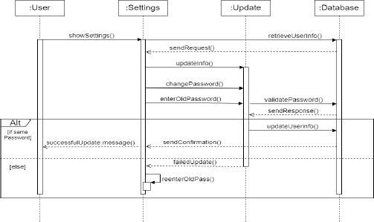

**D: EDIT THE SETTINGS:**

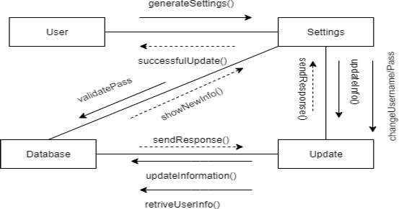

**E: LOG OUT OF THE USER PORTAL:**

The steps to log out, follow as below: User – Dashboard – Log out and then end of the session. The end of the session is followed by the end of the confirmation, that is sent to the user’s personal display. It comes up and a small .text box item.

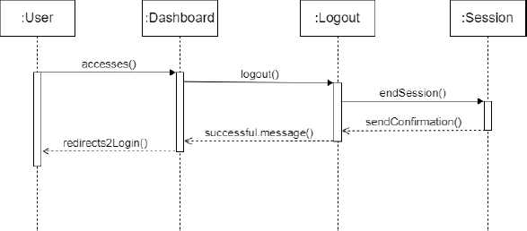

**F: LOG OUT – PART 2; RETREIVE ACCESS AND LOG OUT.**

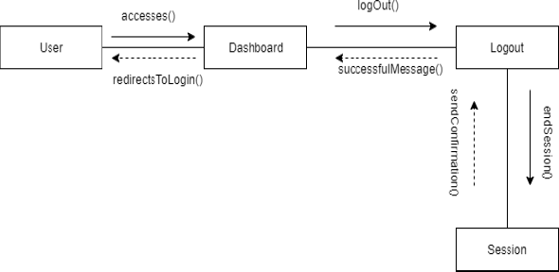

We follow these steps:

* User to Software.
* Dashboard to the log out session, here we either send successfulMessage(), or we insert the endSession().

**G: ADD A CV APPOINTMENT AND DATE OF SUBMISSION:**

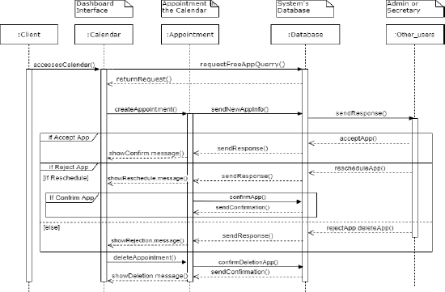

**H: EDIT SUBMISSION AND DATE OF JOB APPLICATION, TO WHEN THE APPLICANT IS AVAILABLE.**

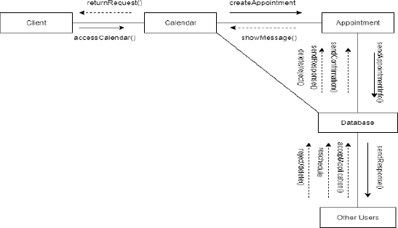

**I: ADD EMPLOYEE OR DELETE FROM THE PORTAL, WHEN HE UNSUBSCRIBES:**

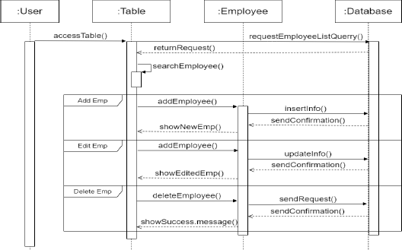

**J: REGISTER, ADD OR DELETE EMPLOYEE:**

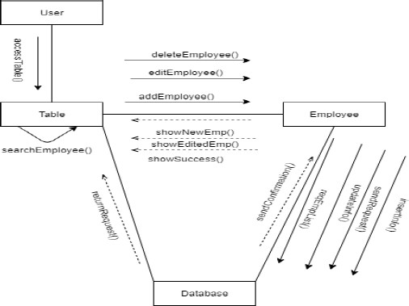

**K: CHANGE, APPROVE OR REJECT EMPLOYEE FROM THE APPLICATION:**

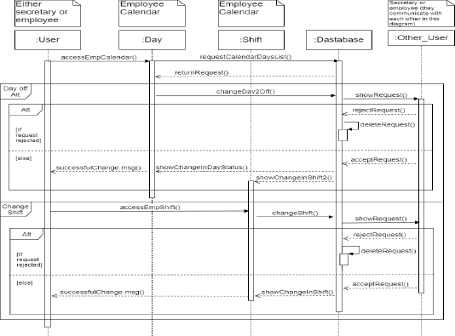

**DOWNLOAD BILL INVOICE FROM THE SOFWARE, based on how much you paid for the onboarded people:**

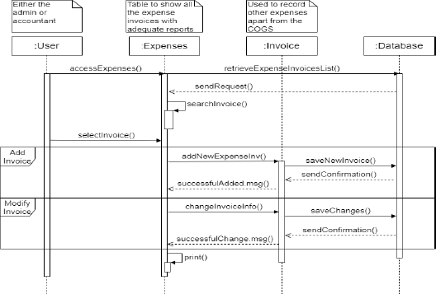 6 -

**ACCOUNTING FORMULAS**, based on the expenses each of the interested parties, here the employee and the interested hire, so businesses, different corporates and hiring companies.

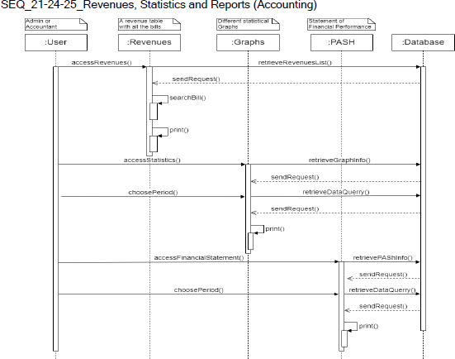

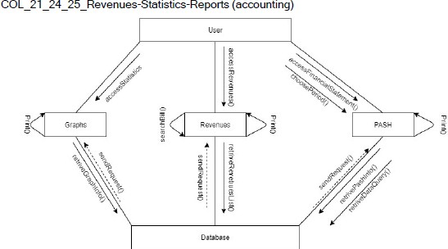

**7 – REGISTER CLIENT ACCOUNT:**

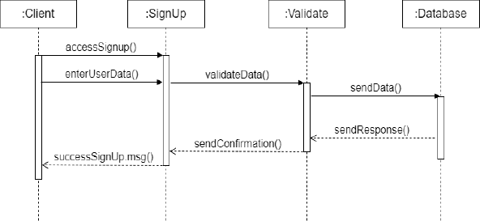The logic follows as seen below:

1. Go to the website or platform's homepage.
2. Look for a "Sign Up" or "Register" button/link.
3. Click on the button/link to start the registration process.
4. Provide your personal

information, such as your name, email address, and password.

1. Follow any additional steps or prompts, such as verifying your email address or setting up security questions.
2. Submit your registration information and wait for confirmation that your account has been created.

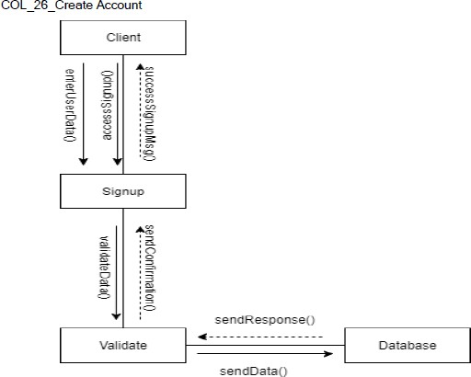

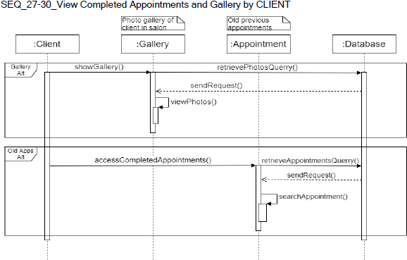

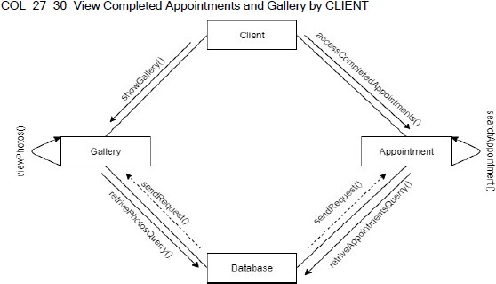

Finally, to check on how many applications were done under each account, we will have to go through these steps:

1. Gallery check – 2. Client name/company underwritten in. – 3. Appointment made under which job position. – 4. Database input in. This goes in an infinite circle, inputting all data in, one by one, per employee and job description.

***SEQ_37-38_View and Deactivate Clients***

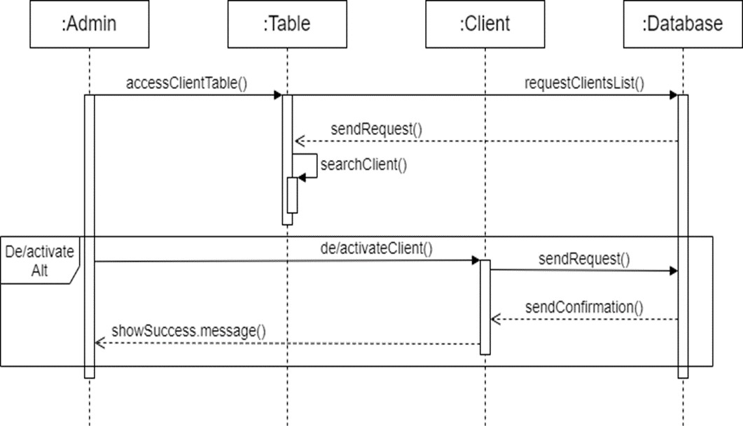

***COL_37-38_View and Deactivate Clients***

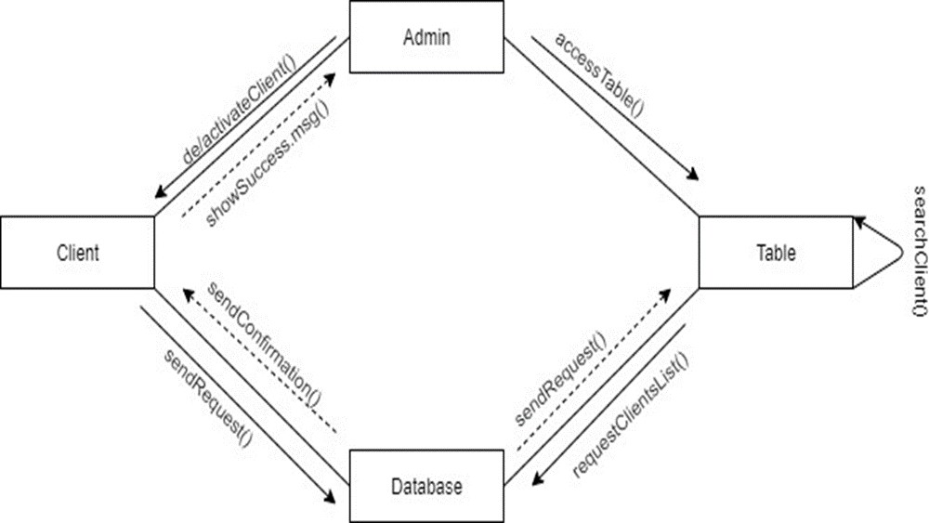

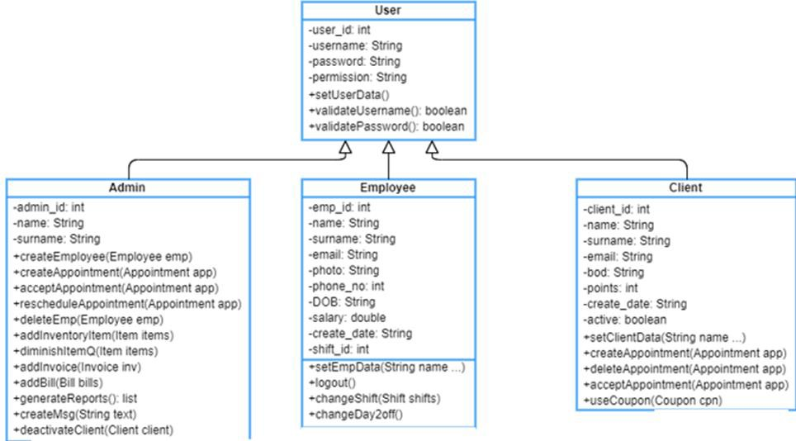***Class Diagram***

***A class diagram is a type of UML diagram that represents the structure of a system or software application in terms of classes, their attributes, and their relationships with other classes. Here are the main components of a class diagram:***

***Class:*** A class is a blueprint for an object in the system. It contains attributes that describe the object's state and methods that define its behavior.

**Attribute**: An attribute is a characteristic or property of a class that describes the object's state. It is represented as a name-value pair.

**Method:** A method is a function or behavior that a class can perform. It is represented as a name with optional parameters and return type.

**Association**: An association represents a relationship between two classes. It describes how objects of one class are related to objects of another class. An association can be unidirectional or bidirectional.

**Multiplicity:** Multiplicity is used to indicate the number of objects that participate in an association. It is represented as a range of values, such as "0..1" or "1..*".

**Inheritance:** Inheritance is a mechanism that allows a new class to be based on an existing class, inheriting its attributes and methods. It is represented as an arrow with an open triangle pointing to the base class.

**Interface:** An interface defines a set of methods that a class can implement. It is represented as a rectangle with the stereotype <<interface>>.

**Stereotype:** A stereotype is a tag that provides additional information about a class or other UML element. It is represented as a name in guillemets, such as <<abstract>> or

<<enumeration>>.

Class diagrams are useful for visualizing the structure of a system and can be used during the design and development phases of software development. They can also be used for communication between developers, stakeholders, and users.

***Component and Deployment Diagrams***

***Co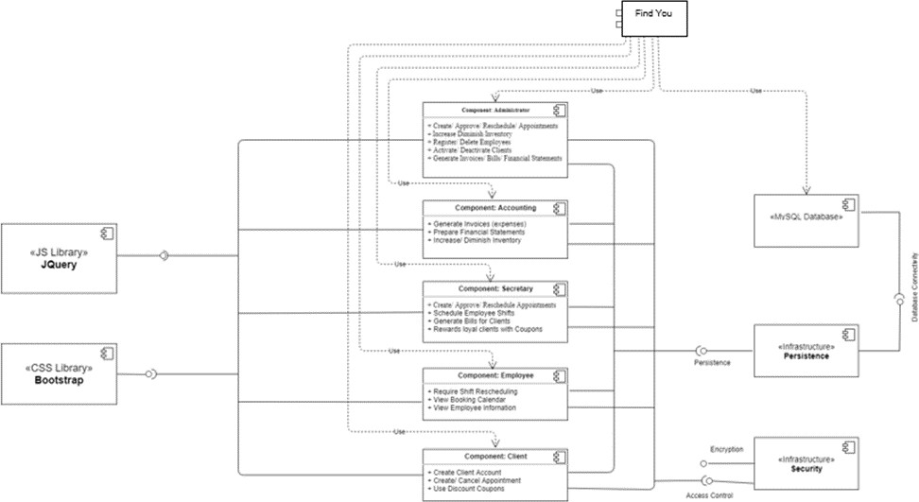m***